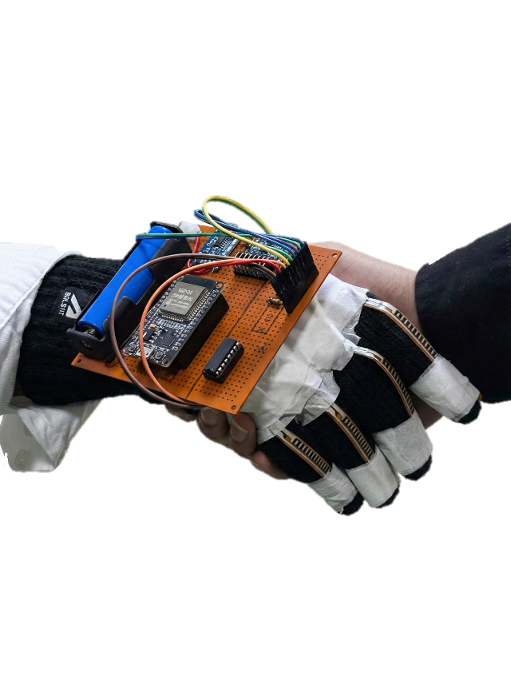
RPW1 (CSE3918)
SIKSHA ‘O’ ANUSANDHAN (DEEMED TO BE UNIVERSITY)

A MACHINE LEARNING FRAMEWORK FOR SENSOR-BASED SIGN LANGUAGE GESTURE RECOGNITION USING WEARABLE DEVICES

Centre for IoT, Institute for Technical Education and Research

Index
- Abstract
- Keywords
- Introduction
- Problem Formulation
- Feature Representation and Dataset Construction
- Data Preprocessing
- Model Selection and Theoretical Background
- Algorithmic Design
- Performance Evaluation Metrics
- Computational Complexity Analysis
- Comparative Analysis
- System-Level Machine Learning Pipeline
- Conclusion
- Future Work

A Machine Learning Framework for Sensor-Based Sign Language Gesture Recognition Using Wearable Devices

Abstract
Sign language serves as a primary communication medium for individuals with hearing and speech impairments; however, its usability remains limited when interacting with non-signers. This paper presents a comprehensive machine learning framework for real-time sign language gesture recognition using wearable sensor data. The proposed system formulates gesture recognition as a supervised multiclass classification problem and employs structured numerical features derived from flex sensors and inertial measurement units. A complete end-to-end pipeline is developed, encompassing dataset construction, preprocessing, feature scaling, model training, real-time inference, and temporal stabilization. A Random Forest classifier is selected based on its robustness, low inference latency, and suitability for embedded deployment. Mathematical foundations, algorithmic design, and computational complexity analysis are presented in detail. Experimental evaluation demonstrates that classical ensemble-based learning, when carefully engineered, provides an efficient and reliable solution for real-time assistive communication systems.

Keywords
Sign Language Recognition, Machine Learning, Random Forest, Wearable Sensors, Gesture Classification, Embedded AI

1. Introduction
Communication barriers between hearing-impaired individuals and the general population remain a significant social challenge. While sign language is an effective medium of expression, its adoption among non-signers is limited. Recent advances in wearable sensing and machine learning have enabled intelligent assistive systems capable of translating hand gestures into readable text.
This work focuses on the machine learning methodology underlying a sensor-based sign language translator using a smart glove, building upon prior research in gesture recognition and wearable sensing systems ^{[7], [9]}. Unlike vision-based approaches, which are sensitive to lighting conditions and background noise, the proposed framework relies exclusively on sensor-derived numerical features, ensuring robustness and portability. The primary contribution of this paper is a mathematically grounded, computationally efficient, and deployment-ready machine learning framework suitable for real-time embedded systems.

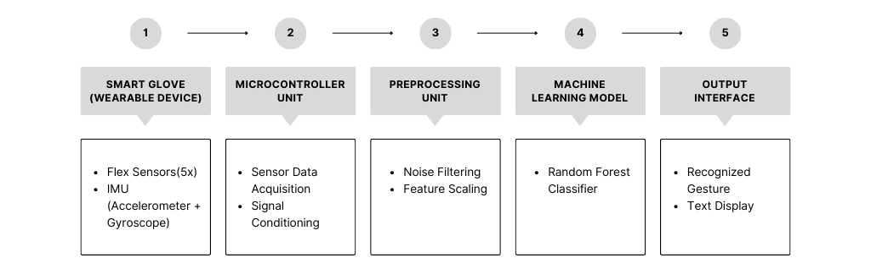
Figure 1.1 System architecture of the proposed wearable sign language gesture recognition system.

2. Problem Formulation
The gesture recognition task is formulated as a supervised multiclass classification problem. Let the dataset be defined as:
$$D = \{(x₁, y₁), (x₂, y₂), …, (xₙ, yₙ)\}$$
where xᵢ ∈ ℝ¹¹ represents the sensor-derived feature vector at time i, and yᵢ ∈ {c₁, c₂, …, cₖ} denotes the corresponding gesture label. The objective is to learn a mapping function:
$$f : R¹¹ → \{c₁, c₂, …, cₖ\}$$
that minimizes classification error while satisfying real-time inference constraints.

3. Feature Representation and Dataset Construction
Each gesture instance is represented by an 11-dimensional feature vector consisting of five flex sensor readings and six inertial measurements (three accelerometer and three gyroscope values). These features collectively encode finger articulation, hand orientation, and angular motion.
Due to the absence of public datasets matching the chosen sensor configuration, a custom dataset was constructed. Multiple samples were recorded for each gesture to capture intra-class variability arising from natural hand motion and sensor noise. This domain-specific dataset significantly improves generalization during deployment.

4. Data Preprocessing
Raw sensor data undergoes systematic preprocessing prior to model training. Invalid samples are removed, duplicate entries are eliminated, and physically implausible sensor values are filtered. Noise reduction is performed using a rolling mean filter, a commonly used technique in sensor-based activity recognition ^{[9]}:
$$x̄ᵢ = (1/w) Σⱼ₌ᵢ₋w₊₁ᵢ xⱼ$$
To ensure uniform feature contribution, standardization is applied as:
$$z = (x - μ) / σ$$
Dataset balancing is performed to mitigate class imbalance and prevent biased learning.

5. Model Selection and Theoretical Background
The structured and non-linear nature of sensor data motivates the use of ensemble learning. A Random Forest classifier is selected due to its robustness to noise, resistance to overfitting, and low inference latency, as established in ensemble learning literature ^{[2], [5]}.
A Random Forest consists of an ensemble of decision trees trained using bootstrap aggregation, originally formalized by Breiman ^{[2]}. Each tree maximizes information gain during splitting, defined as:
$$IG(S) = H(Y) - Σₖ (|Sₖ| / |S|) H(Yₖ)$$
where entropy H(Y) is given by:
$$H(Y) = - Σᵢ pᵢ log₂ pᵢ$$
Final prediction is obtained through majority voting across all trees.

6. Algorithmic Design

Algorithm 1: Dataset Preprocessing
Input: Raw dataset D_raw Output: Clean dataset D_clean
- Remove missing and duplicate samples
- Filter invalid sensor ranges
- Apply rolling mean smoothing
- Normalize labels and balance classes
- Standardize features
- Return D_clean

Algorithm 2: Model Training
Input: D_clean Output: Trained model M, scaler S
- Perform stratified train–test split
- Compute μ and σ from training set
- Train T decision trees on bootstrapped samples
- Aggregate trees into Random Forest
- Serialize model and scaler

Algorithm 3: Real-Time Inference
Input: Live sensor stream xₜ Output: Stabilized prediction ŷ
- Standardize xₜ using S
- Compute class probabilities using M
- Apply confidence threshold
- Perform majority voting over sliding window
- Output final gesture

7. Performance Evaluation Metrics
Model performance is evaluated using accuracy, precision, recall, and F1-score:
$$Accuracy = (TP + TN) / (TP + TN + FP + FN)$$
$$Precision = TP / (TP + FP)$$
$$Recall = TP / (TP + FN)$$
$$F1 = 2 · (Precision · Recall) / (Precision + Recall)$$
A confusion matrix is used to analyze class-wise performance and misclassification patterns.

8. Computational Complexity Analysis
Training complexity of the Random Forest is:
$$O(T · n · d · log n)$$
Inference complexity per sample is:
$$O(T · log n)$$
Preprocessing operations are linear in feature dimension O(d), and memory complexity is O(T · n). These characteristics ensure feasibility on embedded platforms.

9. Comparative Analysis
Compared to SVMs, Random Forests scale better for multiclass problems and provide faster inference, particularly in embedded and real-time settings ^{[5]}. Deep learning models such as LSTMs require significantly larger datasets and incur higher computational costs ^{[3], [4]}, making them less suitable for real-time embedded deployment in the current context.

10. System-Level Machine Learning Pipeline
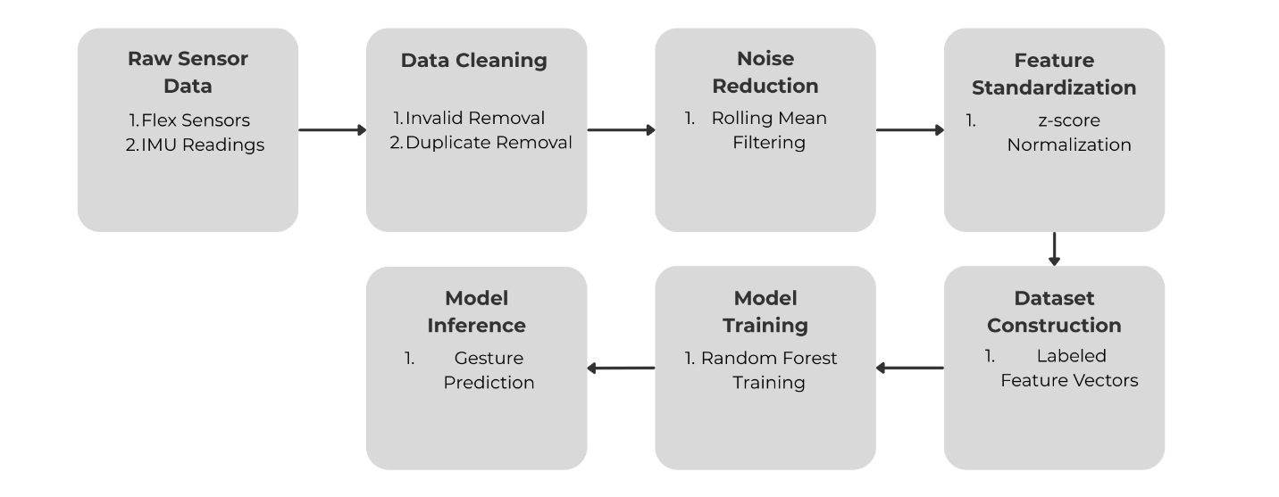
Figure 1.2 Machine learning pipeline for sensor-based gesture recognition.
The proposed pipeline consists of sensor data acquisition, feature construction, preprocessing, model inference, confidence filtering, temporal stabilization, and output generation, consistent with standard human activity recognition pipelines ^{[8], [9]}. This end-to-end design ensures low latency, stability, and robustness under real-world conditions.

11. Conclusion
This paper presents a complete research-grade machine learning framework for wearable sign language gesture recognition. By combining principled feature engineering, ensemble-based learning, and real-time inference stabilization, the system achieves reliable performance under embedded constraints. The results demonstrate that classical machine learning models, when rigorously designed, remain highly effective for assistive technologies and real-world AI deployments.

References
[1] T. Ojala, M. Pietikäinen, and D. Harwood, “A comparative study of texture measures with classification based on featured distributions,” Pattern Recognition, vol. 29, no. 1, pp. 51–59, 1996.
[2] L. Breiman, “Random forests,” Machine Learning, vol. 45, no. 1, pp. 5–32, 2001.
[3] I. Goodfellow, Y. Bengio, and A. Courville, Deep Learning. MIT Press, 2016.
[4] C. M. Bishop, Pattern Recognition and Machine Learning. Springer, 2006.
[5] J. Friedman, T. Hastie, and R. Tibshirani, The Elements of Statistical Learning. Springer, 2001.
[6] R. C. Gonzalez and R. E. Woods, Digital Image Processing, 4th ed. Pearson, 2018.
[7] S. Mitra and T. Acharya, “Gesture recognition: A survey,” IEEE Transactions on Systems, Man, and Cybernetics, vol. 37, no. 3, pp. 311–324, 2007.
[8] D. Anguita et al., “A public domain dataset for human activity recognition using smartphones,” ESANN, 2013.
[9] A. Bulling, U. Blanke, and B. Schiele, “A tutorial on human activity recognition using body-worn inertial sensors,” ACM Computing Surveys, vol. 46, no. 3, 2014.
[10] P. Viola and M. Jones, “Robust real-time object detection,” International Journal of Computer Vision, vol. 57, no. 2, pp. 137–154, 2004.

